Why I can’t open the survey?
If you are unable to open the survey, please follow the steps below:

Step 1 :
Copy the URL from the email body as shown below.
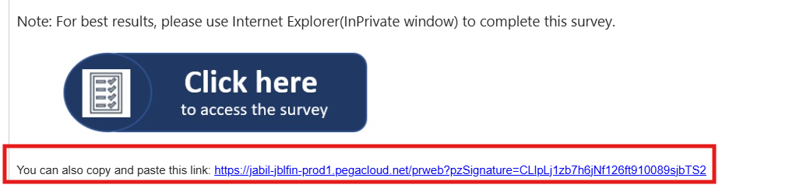

Step 2:
Open the survey link using a Private / InPrivate / Incognito window in your browser, as shown below.
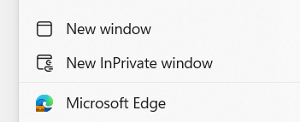

Step 3 :
Paste the URL copied in Step 1 into the address bar, as shown below.

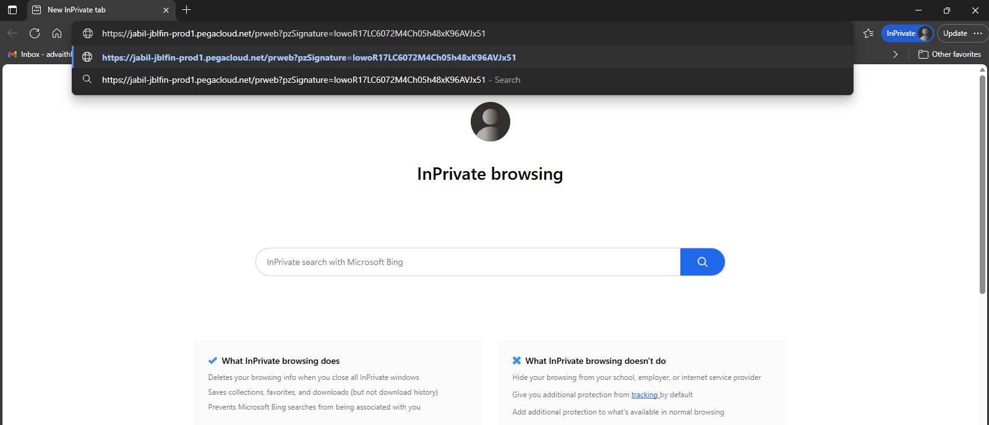

Step 4 :
A pop-up box will appear. Please read the instruction and click Close to proceed.

