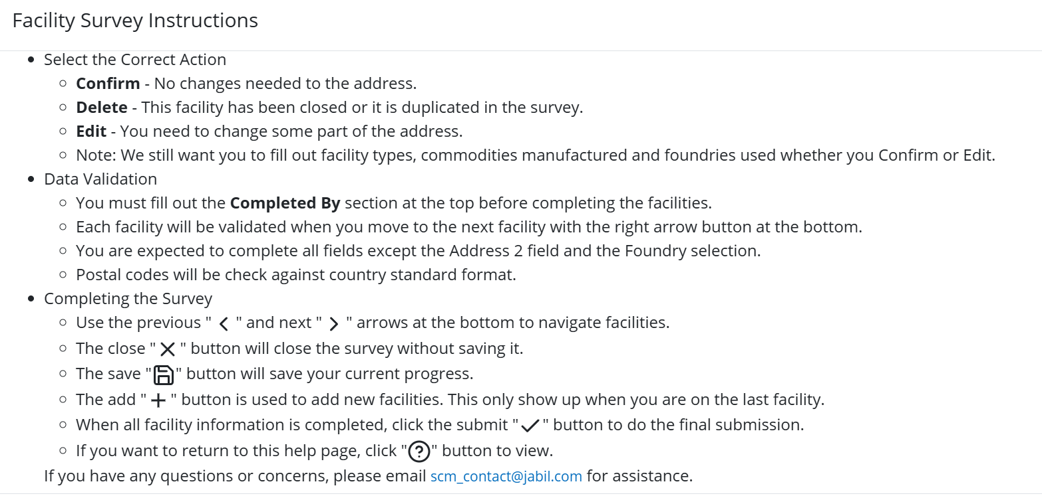

After logging in, please complete all required fields:
- Survey completed by
- Facility information – Confirm/Edit/Delete
- sub-contractor location
- Facility Types
- Commodities
Once all required fields are filled in, click the “Next >” button to proceed to the next facility location.
After completing all facility information, click the “Submit” ✔️ button to finalize and submit the survey.

