How to Submit the Questionnaire Successfully
After you finish all the questions, click the SUBMIT button at the top right or bottom right of the questionnaire.
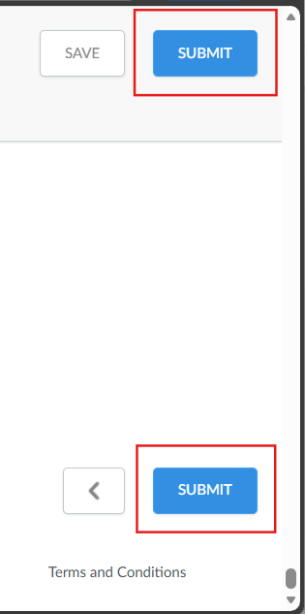

Next, click SUBMIT again in the pop-up window.
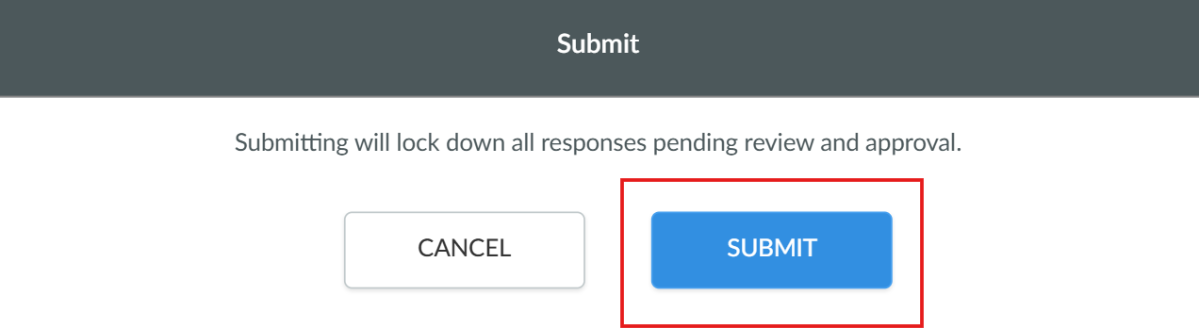

When the questionnaire status shows “Completed” on the landing page, it means your submission was successful.
