The Questionnaire Cannot Be Submitted
If you see the “Complete Missing Fields” pop-up message after clicking “SUBMIT”, it means some questions are still incomplete.
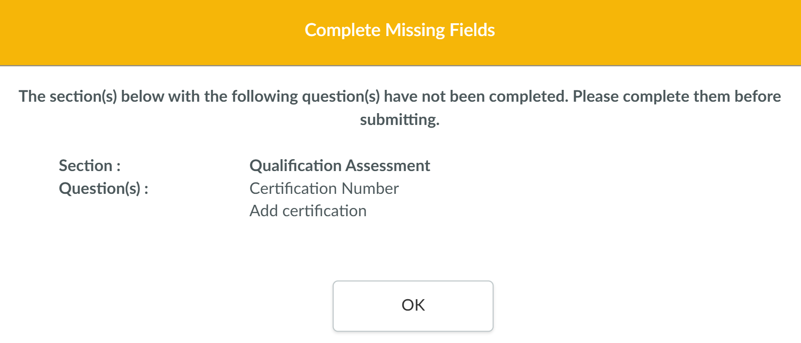

If you notice red dash icons next to any section, it indicates that there are unanswered questions in that section.
