Why does the system keep showing “Locked for 2 hours,” and why can’t I log in?

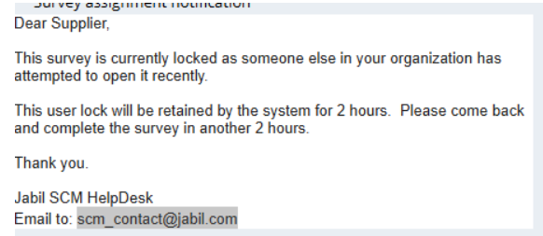

Solution:
The system will automatically lock when more than one person logs in using the same account at the same time. To avoid this issue, please ensure that only one user accesses the system.
Please wait 2 hours before attempting to log in again.
Before logging in, kindly clear your browser history/cache and use Internet Explorer to log in again.



