The Link Cannot Be Opened
If you click the link and the questionnaire does not appear, please try one of the following methods to access it:
- Open the link in private/incognito mode in your current browser.
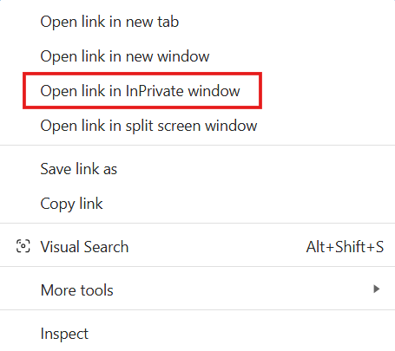

- Clear your browsing history/cache in your current browser.
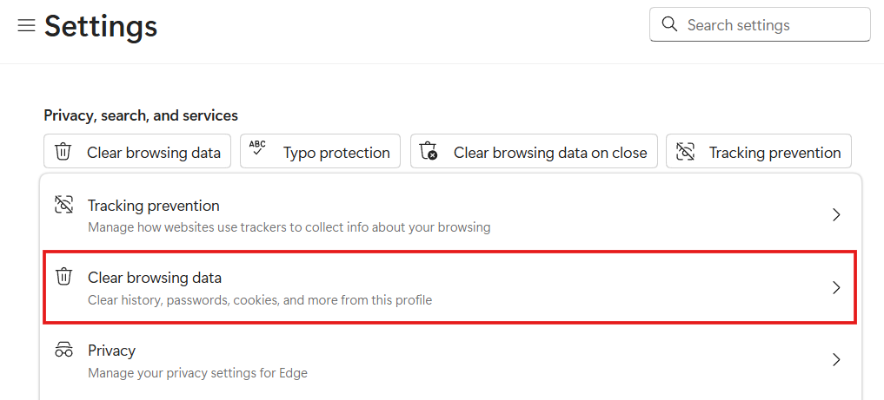

- Try using a different browser (e.g., Google Chrome, Microsoft Edge, Safari, or Firefox).

