Selecting the Type of Products Your Company Supplies to Jabil
In Question 1 of the Qualification Assessment section, one sub-question asks you to select the type of products your company supplies to Jabil.
You must select at least one product type or commodity.
If you select “Not Applicable” for all three commodities, the questionnaire will be returned to you for correction, as this response is not acceptable.
Please refer to the examples below to see how to answer this question correctly.

Incorrect response for commodities type
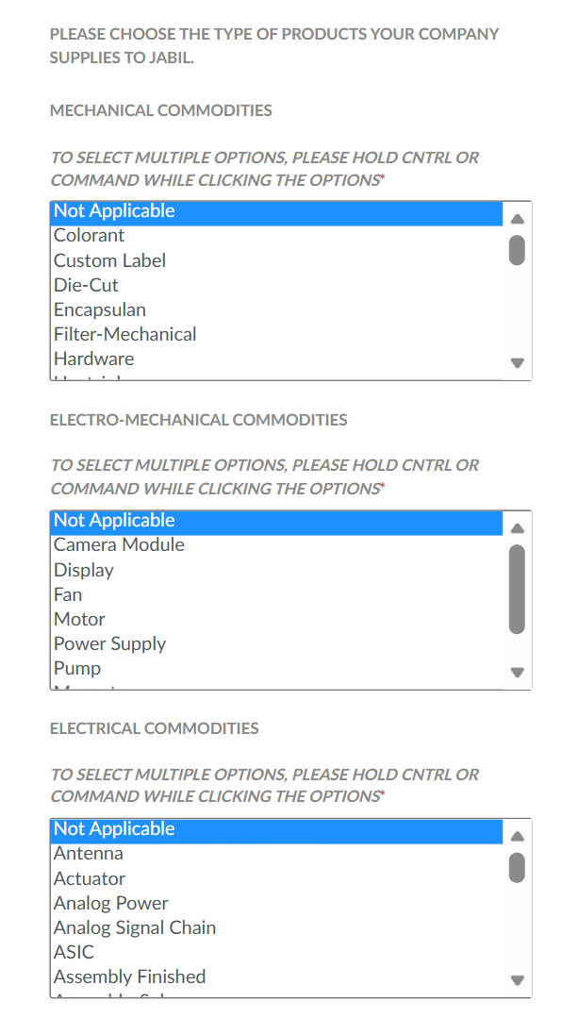

How to answer this question correctly
Example 1  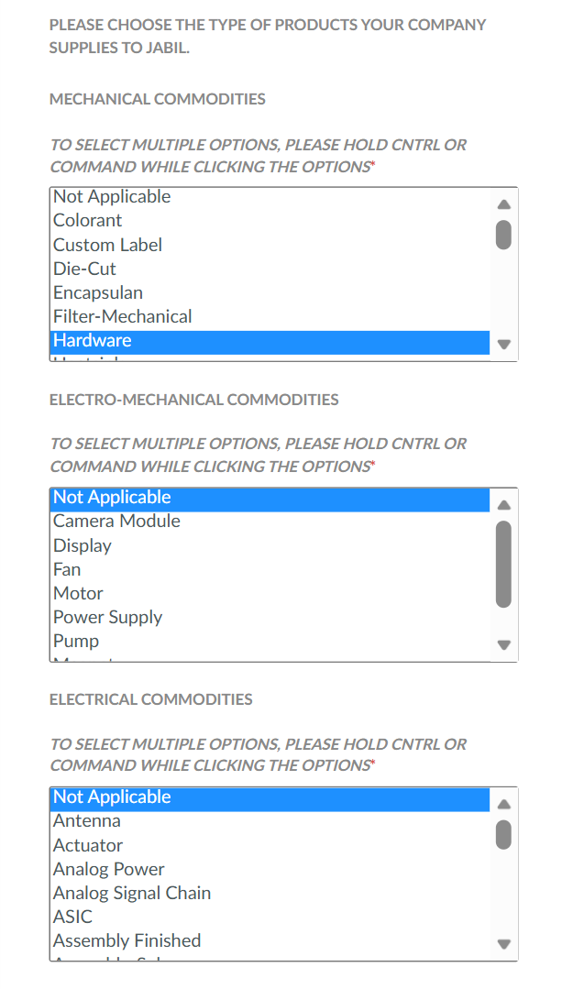 | Example 2  